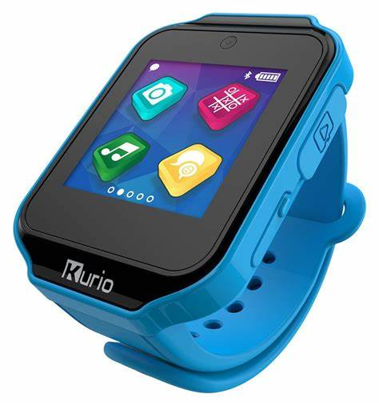**Description:** Kurio is a brand known for its kid-friendly technology, including smartwatches and tablets designed specifically for children. Kurio smartwatches offer a safe and engaging way for kids to stay connected while incorporating fun features like games, fitness tracking, messaging, and parental controls.

Many Kurio smartwatches include features such as a built-in camera, customizable watch faces, Bluetooth connectivity, and activity trackers. Some models also allow kids to send messages, emojis, and photos to pre-approved contacts. Designed for safety, Kurio devices often come with GPS tracking, geofencing, and limited internet access, ensuring a secure digital experience for young users.

Kurio watches are durable, lightweight, and designed to withstand children's daily activities. They provide an excellent alternative to smartphones for younger kids, offering entertainment and communication in a controlled environment.